Business Problem:

In recent years, both City Hotel and Resort Hotel have been grappling with high cancellation rates, leading to various issues such as decreased revenue and underutilized hotel rooms. Addressing the challenge of reducing cancellation rates is a top priority for both hotels to enhance revenue generation and improve overall operational efficiency. This report aims to analyse hotel booking cancellations while excluding irrelevant factors and focusing on revenue generation.

Assumption:

* No significant unforeseen events occurred between 2015 and 2017 that would significantly impact the analyzed data.
* The data used in this analysis is still current and relevant for making effective business decisions.
* The hotels are not currently utilizing any of the suggested strategies.
* Booking cancellations have the most substantial impact on revenue generation.
* Cancellations result in vacant rooms for the entire duration of the originally booked stay.

Research Question :

1. What are the variables that affect hotel reservation cancellations?

2. How can we make hotel reservations cancellations better?

3. How will hotels be assisted in making pricing and promotional decisions?

Hypothesis :

* More cancellations occur when prices are higher.
* When there is a longer waiting list, customers tend to cancel more frequently.

Analysis & Findings:

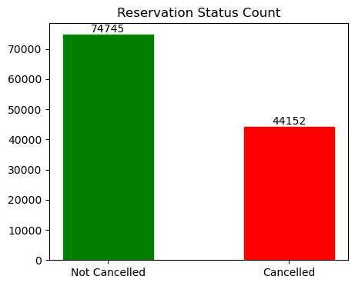

The bar graph depicts the proportion of cancelled and non-cancelled reservations. It is evident that a considerable percentage of reservations remain unaffected by cancellations. However, approximately 37% of clients have cancelled their reservations, significantly impacting the hotel’s earnings.

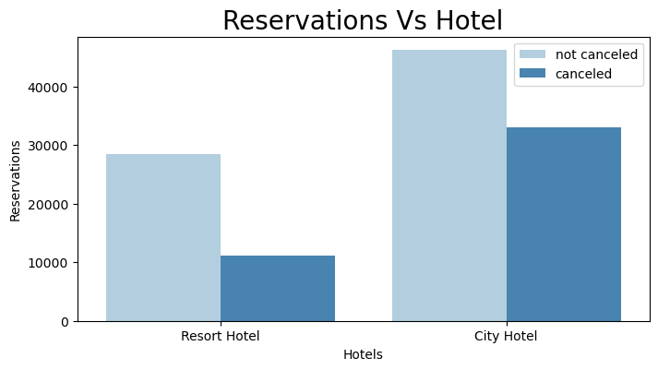

City hotels tend to receive more bookings compared to resort hotels. This observation aligns with the hypothesis that resort hotels may experience lower demand due to potentially higher prices compared to hotels in city locations.

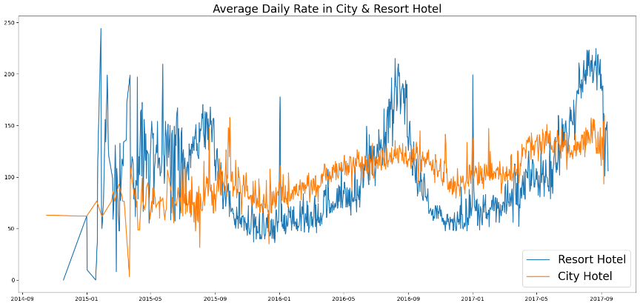

The line graph illustrates that, on average, the daily rates at city hotels are lower compared to resort hotels. Additionally, it indicates a potential increase in prices during weekends and holidays.

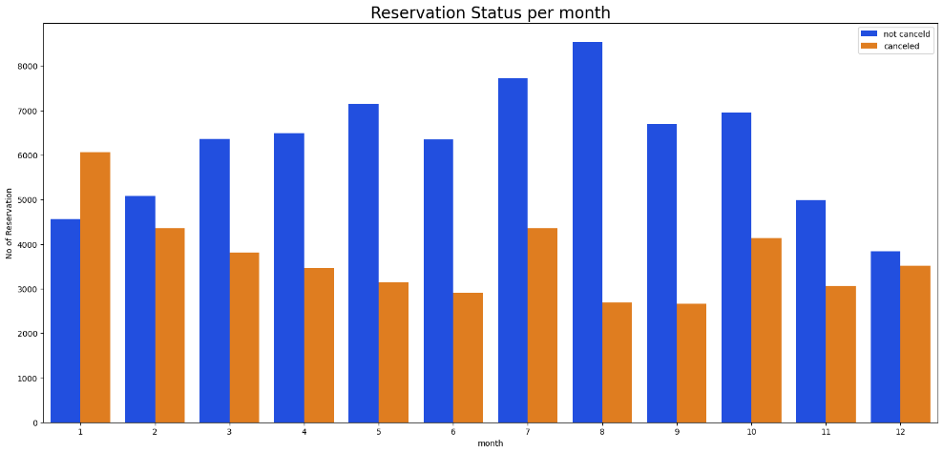

The grouped bar graph allows us to analyse the months with the highest and lowest reservation levels based on their status. It is evident that confirmed reservations reach their peak in August, indicating high activity during that month. However, January stands out as the month with the highest number of cancelled reservations, suggesting a significant trend of cancellations during that period.

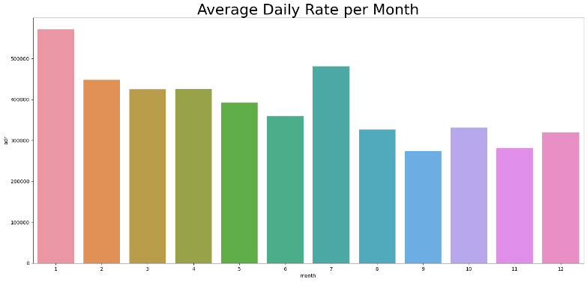

The bar graph clearly indicates that cancellations are more prevalent when prices are higher and less common when prices are lower. This suggests that the cost of accommodation is a significant factor influencing reservation cancellations.

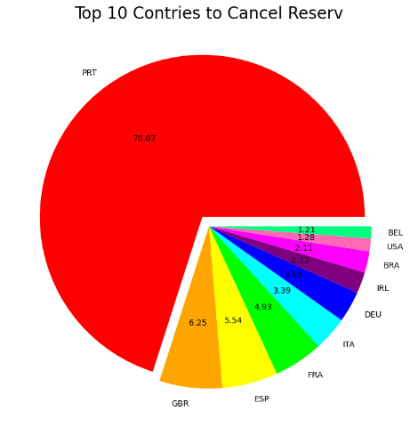

Furthermore, analyzing the highest number of reservation cancellations by country reveals that Portugal has the highest count of cancellations among all countries.

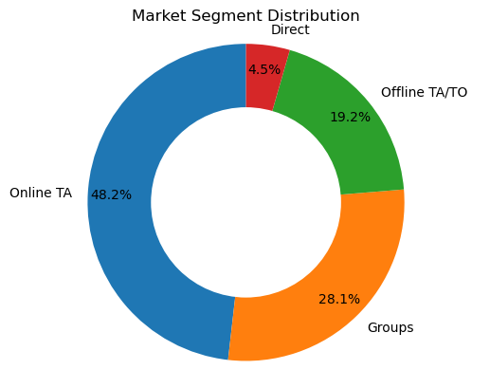

To analyse the source of guests and their reservation methods, let's consider the categories of Direct, Groups, Online Travel Agents, and Offline Travel Agents. Based on the data, approximately 46% of clients make their hotel reservations through online travel agencies, while 27% of clients come from group bookings. Only a small portion, around 4%, choose to book hotels directly by visiting them in person. The Customer type which cancel most often is Transient with 82% cancellation rate.

Suggestions:

* Pricing Strategies: To reduce reservation cancellations, hotels can consider revising their pricing strategies. Lowering rates for specific hotels based on locations or offering discounts and promotions can incentivize customers to keep their reservations and discourage cancellations.
* Weekend and Holiday Discounts: Since the resort hotel has a higher cancellation ratio compared to city hotels, offering reasonable discounts on room prices during weekends or holidays can attract more bookings and reduce cancellations in the resort hotel segment.
* January Campaigns: As January experiences a higher cancellation rate, hotels can launch targeted campaigns or marketing initiatives during this month. Offering special promotions or packages during this period can encourage guests to retain their reservations, helping to increase revenue.
* Focus on Quality and Services: Improving the quality of hotels and enhancing services, particularly in Portugal where cancellation rates are high, can contribute to reducing cancellation rates. Providing an excellent guest experience and exceeding customer expectations can make guests less likely to cancel their reservations.
* To minimize the significant cancellations facilitated by online travel agents, it is crucial to ensure that the pictures and services displayed online align accurately with the actual offerings of the hotels. Maintaining consistency between online representations and the real experience can enhance customer satisfaction and reduce the likelihood of cancellations stemming from mismatched expectations.